SANSKAAR PATNI
180905134 CSE C 23
CD LAB 9

1.PARSER CODE FOR DECISION MAKING AND LOOPING STATEMENTS

#include<stdio.h>
#include<stdlib.h>
#include<string.h>
#include<fcntl.h>
#include "symbolTable.c"

struct Token retToken;
FILE *fp;

void match();
void Program();
void declarations();
int data_type();
void identifier_list();
void identifier_listprime();
void identifier_listprimeprime();
void statement_list();
int statement();
int assign_stat();
void expn();
void eprime();
void simple_expn();
void seprime();
void term();
void tprime();
void factor();
int decision_stat();
void dprime();
int looping_stat();
int relop();
int addop();
int mulop();

void valid()
{
printf("\n----------PARSER SUCCESS!----------\n\n");
exit(0);
}

void invalid(char *follow)
{
printf("\n----------PARSER ERROR!----------\n\n");
printf("Error reported at row no. %d column no. %d\n",retToken.row, retToken.col);
printf("Expected %s\n", follow);
exit(0);
}

int main(int argc, char const *argv[])
{
fp = fopen(argv[1], "r");
if (fp == NULL){
printf("Cannot open file \n");
exit(0); }
//printf("File opened\nParsing Started\n");
Program();
//printSymbolTable();
//printf("Im in main after parsing\n");
/*if(strcmp(retToken.token_name,"eof")==0||feof(fp))
valid();
else
invalid("EOF");*/
if(retToken.row == -1)valid();
else invalid("EOF");
}

void match()
{
//printf("Inside Match\n");
retToken=getNextToken(fp);
if(retToken.row == -1)
return;
if(strcmp(retToken.token_name,"eof")==0)
return;
printToken(retToken);
}

void Program()
{
match();
if(strcmp(retToken.token_name,"main")==0)
{
match();
if(strcmp(retToken.token_name,"(")==0)
{
match();
if(strcmp(retToken.token_name,")")==0)
{
match();
if(strcmp(retToken.token_name,"{")==0)
{
match();
declarations();
statement_list();
if(strcmp(retToken.token_name,"}")==0)
{
//printf("Reached here\n");
match();
}
else
{
invalid("}");
}
}
else
{
invalid("{");
}
}
else
{
invalid(")");
}
}
else
{
invalid("(");
}
}
else
{
invalid("main");
}
}

void declarations()
{
if(data_type())
{
identifier_list();
if(strcmp(retToken.token_name,";")==0)
{
match();
declarations();
}
else
{
invalid(";");
}
}
}

int data_type()
{
if(strcmp(retToken.token_name,"int")==0 )
{
match();
return 1;
}
else if(strcmp(retToken.token_name,"char")==0 )
{
match();
return 1;
}
else
{
return 0;
}
}

void identifier_list()
{
if(strcmp(retToken.token_name,"id")==0)
{
match();
identifier_listprime();
}
else
{
invalid("id");
}
}

void identifier_listprime()
{
if(strcmp(retToken.token_name,",")==0)
{
match();
identifier_list();
}
else if(strcmp(retToken.token_name,"[")==0)
{
match();
if(strcmp(retToken.token_name,"num")==0)
{
match();
if(strcmp(retToken.token_name,"]")==0)
{
match();
identifier_listprimeprime();
}
else
{
invalid("]");
}
}
else
{
invalid("num");
}
}
}

void identifier_listprimeprime()
{
if(strcmp(retToken.token_name,",")==0)
{
match();
identifier_list();
}
}

void statement_list()
{
if(statement())
{
statement_list();
}
}

int statement()
{
if(assign_stat())
{
if(strcmp(retToken.token_name,";")==0)
{
match();
return 1;
}
else
{
invalid(";");
}
}
else if(decision_stat())
{

}
else if(looping_stat())
{

}
else
{
return 0;
}
}

int assign_stat()
{
if(strcmp(retToken.token_name,"id")==0)
{
match();
if(strcmp(retToken.token_name,"=")==0)
{
match();
expn();
return 1;
}
else
{
invalid("=");
}
}
else
{
return 0;
}
}

void expn()
{
simple_expn();
eprime();
}

void eprime()
{
if(relop())
{
simple_expn();
}
}

void simple_expn()
{
term();
seprime();
}

void seprime()
{
if(addop())
{
term();
seprime();
}
}

void term()
{
factor();
tprime();
}

void tprime()
{
if(mulop())
{
factor();
tprime();
}
}

void factor()
{
if(strcmp(retToken.token_name,"id")==0)
{
match();
}
else if(strcmp(retToken.token_name,"num")==0)
{
match();
}
else
{
invalid("id | num");
}
}

int decision_stat()
{
if(strcmp(retToken.token_name,"if")==0)
{
match();
if(strcmp(retToken.token_name,"(")==0)
{
match();
expn();
if(strcmp(retToken.token_name,")")==0)
{
match();
if(strcmp(retToken.token_name,"{")==0)
{
match();
statement_list();
if(strcmp(retToken.token_name,"}")==0)
{
match();
dprime();
}
else
{
invalid("}");
}
}
else
{
invalid("{");
}
}
else
{
invalid(")");
}
return 1;
}
else
{
invalid("(");
}
}
else
{
return 0;
}
}

void dprime()
{
if(strcmp(retToken.token_name,"else")==0)
{
match();
if(strcmp(retToken.token_name,"{")==0)
{
match();
statement_list();
if(strcmp(retToken.token_name,"}")==0)
{
match();
}
else
{
invalid("}");
}
}
else
{
invalid("{");
}
}
}

int looping_stat()
{
if(strcmp(retToken.token_name,"while")==0)
{
match();
if(strcmp(retToken.token_name,"(")==0)
{
match();
expn();
if(strcmp(retToken.token_name,")")==0)
{
match();
if(strcmp(retToken.token_name,"{")==0)
{
match();
statement_list();
if(strcmp(retToken.token_name,"}")==0)
{
match();
dprime();
}
else
{
invalid("}");
}
}
else
{
invalid("{");
}
}
else
{
invalid(")");
}
return 1;
}
else
{
invalid("(");
}
}
else if(strcmp(retToken.token_name,"for")==0)
{
match();
if(strcmp(retToken.token_name,"(")==0)
{
match();
assign_stat();
if(strcmp(retToken.token_name,";")==0)
{
match();
expn();
if(strcmp(retToken.token_name,";")==0)
{
match();
assign_stat();
if(strcmp(retToken.token_name,")")==0)
{
match();
if(strcmp(retToken.token_name,"{")==0)
{
match();
statement_list();
if(strcmp(retToken.token_name,"}")==0)
{
match();
}
else
{
invalid("}");
}
}
else
{
invalid("{");
}
}
else
{
invalid(")");
}
}
else
{
invalid(";");
}
}
else
{
invalid(";");
}
}
else
{
invalid("(");
}
}
else
{
return 0;
}
}

int relop()
{
if(strcmp(retToken.token_name,"==")==0)
{
match();
return 1;
}
else if(strcmp(retToken.token_name,"!=")==0)
{
match();
return 1;
}
else if(strcmp(retToken.token_name,"<=")==0)
{
match();
return 1;
}
else if(strcmp(retToken.token_name,">=")==0)
{
match();
return 1;
}
else if(strcmp(retToken.token_name,">")==0)
{
match();
return 1;
}
else if(strcmp(retToken.token_name,"<")==0)
{
match();
return 1;
}
else
{
return 0;
}
}

int addop()
{
if(strcmp(retToken.token_name,"+")==0)
{
match();
return 1;
}
else if(strcmp(retToken.token_name,"-")==0)
{
match();
return 1;
}
else
{
return 0;
}
}

int mulop()
{
if(strcmp(retToken.token_name,"*")==0)
{
match();
return 1;
}
else if(strcmp(retToken.token_name,"/")==0)
{
match();
return 1;
}
else if(strcmp(retToken.token_name,"%")==0)
{
match();
return 1;
}
else
{
return 0;
}
}

test1.c
main()
{
int a,b,p[25];
char c;
while(a){
if(a<b){
a=a+b*c;
}
else{
if(p){
a=0;
}
}
b=2*c;
}
}

o/p
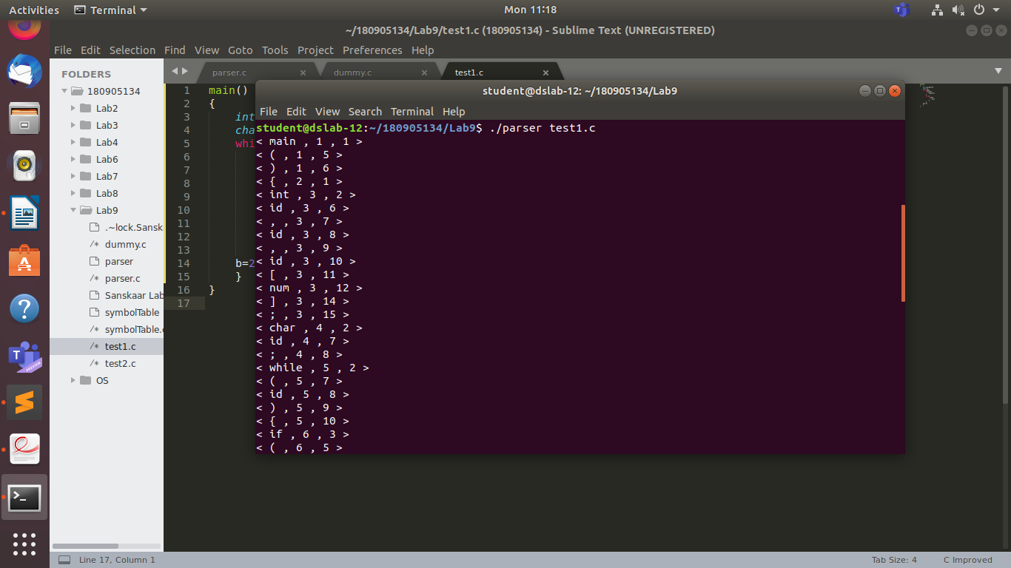
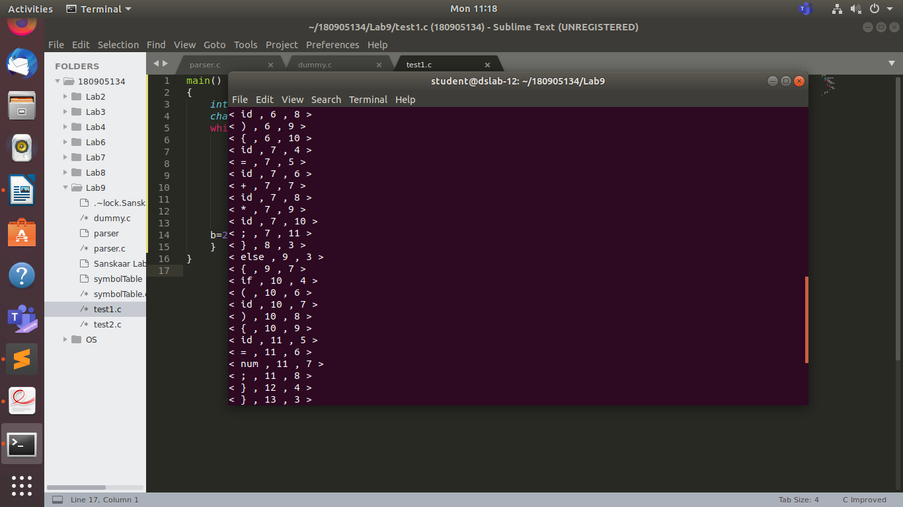
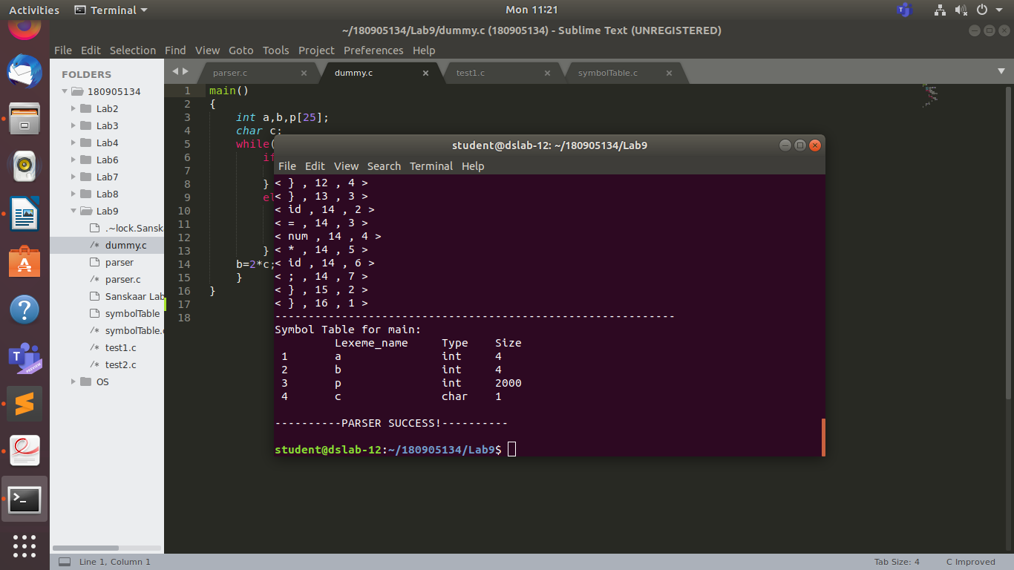
test2.c
main()
{
int a,b,p[25];
char c;
while(a){
if(a b){
a=a+b*c;
}
else{
if(p){
a=0;
}
}
b=2*c;
}
}

o/p:

